ŞİRKET PROFİLİ
Şirket Logosu :
Firma Adı : Namdhari Seeds Tohumculuk Tic. Ltd. Şti.
Adres : Altınova Orta Mah. 19 No’lu Sok. No: 9 Kepez Antalya / TURKEY
Telefon : +90 533 521 10 80
Faks :
E-mail : ayhan.ekici@ttmail.com
Web sitesi :www.namdhariseeds.com
1.KİMLİĞİMİZ
Founded in 1985, Namdhari Seeds initially concentrated on contract seed production for exports. In first decade, it emerged as one of the largest contract seed producer of vegetables and flowers. Simultaneously breeding programs were started to develop suitable hybrids for the Indian market in important vegetable crops. Our first hybrids were released in the Indian market in 1992 which were very successful. Inspired by the success of our hybrids there was an increased emphasis and investment in breeding which resulted into the position of leadership in Indian vegetable seed industry.
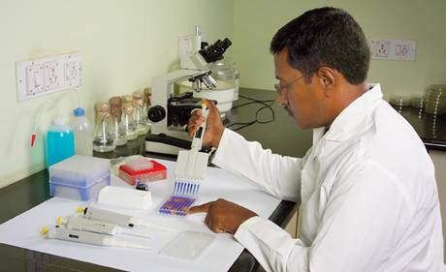
Presently, Namdhari Seeds is one of the largest vegetable seed companies in India. We offer more than 500 hybrids and varieties in 20 different crops globally. Our research team strives to develop suitable hybrids for diverse market requirements. Major emphasis is on regional preferences, adaptability, disease resistance, yield, taste and shelf life. The product development team acts in close co-ordination with R&D and marketing and conducts trials, extensively in the farmer’s fields before releasing to the market. Close interaction of marketing & product development team with the farmers ensures that best products reach the farmer. Although the major concentration of our production is in India, to overcome seasonal limitations, capabilities have been developed to produce seeds in different locations worldwide.
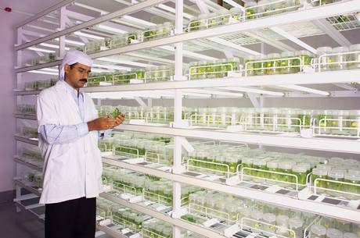
With successes achieved in the domestic scenario, Namdhari Seeds has also expanded its activities to S.E.Asian countries (Bangladesh, Thailand, Vietnam and Indonesia) and Middle East (Egypt, Jordan, Syria and Saudi) besides Turkey. Our hybrids have been accepted in many of these markets. The company has now diversified into field crops and developed cotton and rice hybrids.
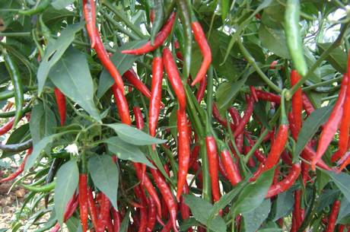
We at Namdhari Seeds understand the importance of the seeds in relation to livelihood and prosperity of the farmer. We have also diversified into production, export and domestic retailing of fresh vegetables through our subsidiaries Namdhari Farm fresh and Namdhari Agro fresh. This has helped us to understand the difficulties of grower and the needs of end customer.
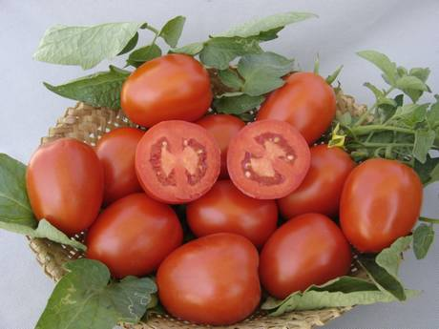
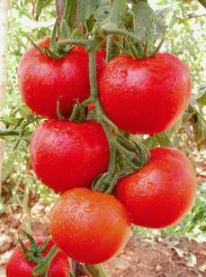
The start has been promising. We are well poised and committed to deliver ‘Seeds for a better future.’

